[Title of the Project]


By:

Full Name – Team Member 1
CMS Number
Full Name – Team Member 2
CMS Number
Full Name – Team Member 3
CMS Number

Supervised by:
[Full Name of Supervisor]

Faculty of Computing
Riphah International University, Islamabad
Spring/Fall 20xx

A Dissertation Submitted To

Faculty of Computing,
Riphah International University, Islamabad
As a Partial Fulfillment of the Requirement for the Award of the Degree of
Bachelors of Science in Computer Science

Faculty of Computing
Riphah International University, Islamabad

Date: [date of final presentation]
Final Approval

This is to certify that we have read the report submitted by name of student(s) (CMS #), for the partial fulfillment of the requirements for the degree of the Bachelors of Science in Computer Science (BSSE). It is our judgment that this report is of sufficient standard to warrant its acceptance by Riphah International University, Islamabad for the degree of Bachelors of Science in Computer Science (BSSE).

Committee:

1 | [Name Supervisor]  (Supervisor)
2 | [Name of HOD/chairman]  (Head of Department/chairman)

Declaration

We hereby declare that this document “[Project Title]” neither as a whole nor as a part has been copied out from any source. It is further declared that we have done this project with the accompanied report entirely on the basis of our personal efforts, under the proficient guidance of our teachers, especially our supervisor [insert name of Supervisor(s)]. If any part of the system is proved to be copied out from any source or found to be reproduction of any project from anywhere else, we shall stand by the consequences.

___________________________
[Name of Student 1]
[CMS #]

___________________________
[Name of Student 2]
[CMS #]

___________________________
[Name of Student 3]
[CMS #]

Dedication
Insert dedication here…
Acknowledgement

First of all we are obliged to Allah Almighty the Merciful, the Beneficent and the source of all Knowledge, for granting us the courage and knowledge to complete this Project.
[Students will acknowledge here anyone who has helped in the project. It can include Supervisor(s), Teachers, Classmates, Friends and Family]

___________________________
[Name of Student 1]
[CMS #]

___________________________
[Name of Student 2]
[CMS #]

___________________________
[Name of Student 3]
[CMS #]

Abstract

Text in 12-Point Size, Times New Roman, 1.5 Line Spacing.

Table of Contents
Table of Contents i
List of Tables iii
List of Figures iv
Abstract 1
Chapter 1: Introduction 2
1.1 Goals and Objectives 2
1.2 Scope of the Project 2
Chapter 2: Literature Review 3
2.1 Introduction 3
2.2 Background and Problem Elaboration 3
2.3 Detailed Literature Review 3
2.3.1 Definitions 3
2.3.2 Related Research Work 1 3
2.3.3 Related Research Work 2 3
2.4 Literature Review Summary Table 3
2.5 Research Gap 3
2.6 Problem Statement 3
Chapter 3: Requirements and Design 4
3.1 Requirements 4
3.1.1 Functional Requirements 4
3.1.2 Non-Functional Requirements 4
3.1.3 Hardware and Software Requirements 4
3.2 Proposed Methodology 4
3.3 System Architecture 4
3.4 Use Cases 4
3.4.1 Sample Use Case Name Here 4
3.5 Database Design (Optional) 6
3.6 Class diagram (Optional) 6
3.7 Sequence diagram (Optional) 6
3.8 Any Other Artifact… 6
3.9 Graphical User Interfaces(GUI) (Optional) 6
Chapter 4: Implementation and Test Cases 7
4.1 Implementation 7
4.1.1 Implementation of First Component/Algorithm 7
4.2 Test case Design and description 7
4.2.1 Sample Test case No.1 7
4.2.2 Sample Test case No.2 7
4.3 Test Metrics 8
4.3.1 Sample Test case Matric.No.1 8
4.3.2 Sample Test case Metric.No.2 8
4.3.3 Sample Test case Metric.No.3 8
Chapter 5: Experimental Results and Analysis 9
Chapter 6: Conclusion and Future Directions 10
References 11
Appendix 12
Appendix A: Guidelines 12
Appendix B: Heading of Sample Appendix B 12
Formatting Guidelines 13
Chapter 1: Heading 1 13
1.1 Heading 2 13
1.1.1 Heading 3 13
Tables and Figures 14
Equations 15
Header/Footer 15
Other Formatting Guidelines 15
References 15

List of Tables
Table 1: This is Sample table caption 1
Table 2: This is Sample table caption 1

List of Figures
Figure 1: List of Styles 1
Figure 2: IEEE Reference style 1

Abstract
An Abstract is a short summary of the work being reported. It should state: the purpose, findings, and conclusion of your work without commenting on or evaluating the work itself. It should be only one paragraph at least half a page long.

Introduction
SpotCancerAI is an inventive project that uses machine learning techniques to detect skin cancer from images of skin lesions. The goal is to improve early diagnosis and provide a reliable tool for healthcare professionals. By analyzing a large dataset (HAM10000) of dermatological images, SpotCancerAI focuses on accurately classifying and segmenting lesions to determine whether they are benign (non-cancerous) or malignant (cancerous). The project grips on advanced image processing methods, including grayscale conversion, gausian blur, and inpainting, to increase the quality of the images before applying machine learning algorithms. Finally, SpotCancerAI aims to assist in the early detection of skin cancer, potentially saving lives by enabling quicker and more correct diseases.

Opportunities
- Early Detection of Skin Cancer :- SpotCancerAI can identify skin cancer at an early stage, which is essential for increasing survival rates. Early detection often leads to simpler and more successful medical care.
- Support for Healthcare Professionals :- The system can act as a determination-support tool for dermatologists and experts by highlighting doubtful lesions, reducing human error, and improving diagnostic correctness.
- Improved Access in Underserved Areas :- In regions with limited approach to skin doctors or specialized care, SpotCancerAI could be integrated into mobile or telemedicine platforms, helping people receive initial evaluations without needing to travel.
- Scalability and Speed :- Unlike standard diagnosis methods, machine learning systems like SpotCancerAI can process thousands of images quickly, making them highly flexible for hospitals and clinics handling large number of patients.
- Educational Tool :- SpotCancerAI can also have a work as an educational support for medical students and trainees, offering a practical understanding of how skin wound are classified and identified using AI.
- Cost-Effective Screening
Computer screening with SpotCancerAI could lower medical care costs by reducing the need for unnecessary biopsies and in-person consultations when wounds are found to be benign.
- Continuous Improvement with Data
The model can be continually improved and retrained with more diverse and updated datasets, leading to better performance over time, especially across different skin tones and lesion types.

1.1.2 Motivation
The motivation at the back of SpotCancerAI project lies in the serious need for early and correct detection of skin cancer, particularly melanoma, which can be life threatening if not diagnosed in time. Traditional diagnostic methods often depend on expert dermatological evaluation, which can be subjective and limited by availability, especially in neglected regions. SpotCancerAI aims to make use the power of artificial intelligence and computer screening to create an accessible, reliable, and efficient tool for skin lesion examination. By computerized screening the detection process using advanced image processing and deep learning techniques, the project seeks to support medical professionals, reduce diagnostic errors, and ultimately improve patient outcomes through faster and more compatible identification of possibly cancerous skin lesions.

1.1.3 Challenges
The SpotCancerAI project faces some challenges that impact its development and successfulness. One major challenge is data quality and diversity—skin wound datasets may lack presentation across different skin tones, age groups, and rare cancer types, which can lead to biased or less accurate models. Another difficulty is the complexity of medical image processing, as skin wounds can vary greatly in appearance due to lighting, image resolution, and surrounding skin features. Segmentation of wound is particularly difficult, requiring precise isolation of the region of interest, which is critical for accurate classification. Additionally, model understandability and clinical validation are essential, as medical professionals need to trust and understand AI-driven decisions before adopting them in practice. Finally, regulatory and ethical concerns around patient data privacy and the deployment of AI in healthcare must be carefully managed to make sure safe and responsible use of the system.

Goals and Objectives

1.2.1 Goals
The Goals of SpotCancerAI are as following :-
- Detect skin cancer using Machine learning and deep learning models.
- Classify different types of skin wounds from images.
- Preprocess images (grayscale, gausian blur, inpainting) for clarity and accuracy.
- Segment lesion areas to isolate them from background skin.
- Support early and correct diagnosis for dermatologists.
- Improve and contribute to Computerized screening or Application in healthcare.
- Share intelligence and tools with the research and developer community.

1.2.2 Objectives

- To use the HAM10000 dataset for training and testing skin diagnosis detection models.
- To clean and enhance the images using preprocessing methods like grayscale conversion, gausian blur, and inpainting.
- To correctly separate (segment) the skin wounds from the rest of the image.
- To train deep learning models that can categorized different types of skin lesions.
- To estimate the model’s performance using accuracy, precision, recall, and F1score.
- To improve the model results by tuning its hyperparameters.
- To build a complete system that goes from image input to final result.
- To support early detection of skin cancer and help in use of medical field.

.

Scope of the Project
The Scope of the Project SpotCancerAI are as following :-
- AI-Based Skin Cancer Detection: Uses deep learning to classify skin lesions.
- Fast & Accurate Results: Provides quick analysis to support medical decisions.
- User-Friendly Interface: Simple and easy-to-use system for both doctors and patients.
- Data Security & Privacy: Ensures patient information is kept safe.
- Mobile & Web Compatibility: Can be used on smartphones and computers.

1.3.1 Project Objectives
- To develop an AI-based system for the early detection of skin wound using dermoscopic images.
- To apply preprocessing techniques such as grayscale conversion, gausian blur, and inpainting for improving image quality.
- To perform correct segmentation of skin wounds from background skin to focus on relevant areas.
- To classify skin wounds into different categories using deep learning models.
- To estimate the performance of the model using standard metrics like accuracy, precision, recall, and F1-score.
- To optimize model performance through setting a hyperparameters.
- To create a complete, end-to-end pipeline from image input to final categorical output.
- To provide a knowledge in medical AI research and support early and efficient disease of skin cancer.

1.3.2 Technological Components
• Dataset:
I. HAM10000 – A large collection of dermoscopic images used for training and training the model.
• Programming Language:
I. Python – Used for data processing, model development, and evaluation.
• Libraries and Frameworks:
- NumPy, Pandas – For data manipulation and analysis.
- OpenCV – For image preprocessing tasks like grayscale conversion, gausian blur, and inpainting.
- Matplotlib, Seaborn – For data visualization.
- Scikit-learn – For preprocessing, model evaluation, and metrics.
- TensorFlow / Keras or PyTorch – For building and training deep learning models.
• Image Preprocessing Tools:
- Grayscale conversion
- Gausian blur (for hair and noise removal) III. Inpainting (to restore cleaned image regions)
• Deep Learning Models:
- Convolutional Neural Networks (CNNs) – Used for image classification and lesion detection.
- (Optional) U-Net or similar architectures – For image segmentation.
- Model Evaluation Metrics:
- Accuracy, Precision, Recall, F1-score – To assess the performance of the classification model.
• Development Environment:
- Jupyter Notebook
- Google Colab
- Kaggle Kernels – For interactive development and experimentation.
• Hardware:
I. GPU (if available) – To accelerate model training and improve performance.

1.3.3 Implementation Phases

I. Problem Understanding & Dataset Selection
- Study the problem of skin cancer detection.
- Select a dataset (HAM10000) for testing and training the model.

II. Data Preprocessing
- Load and run the dataset.
- Apply preprocessing techniques such as: Grayscale conversion ,Gausian Blur , Inpainting
III. Lesion Segmentation
- Implement segmentation techniques to extract the wound from the skin image.

IV. Model Development
- Design and train a Convolutional Neural Network (CNN) for wound categorization.

V. Model Evaluation
- Test the trained model using estimated metrics such as: Accuracy, Precision, Recall, F-1 Score

- Analyze results to identify perfection and imperfection.
VI. Model Optimization
- Tune hyperparameters to improve model performance.
- Apply regularization or data augmentation if needed.

VII. Integration & Final Pipeline
- Combine all steps into one streamlined process.
- Ensure the pipeline works efficiently from input image to diagnosis.

VIII. Documentation & Reporting
- Document all phases, methods, and results.
- Prepare reports or presentations to share findings and show the system.

1.3.4 Data Management
The data management plan for the SpotCancerAI project revolves around the HAM10000 dataset, which provides dermoscopic images and associated metadata such as wound types and lesion location. The dataset is organized into folders for raw images, processed outputs, segmentation masks, training and testing splits, and metadata.
Preprocessing includes mapping lesion codes to readable labels, converting images to grayscale, applying gausian blur, and using inpainting to remove artifacts like hair. All images are resized to a consistent shape (e.g., 224x224) to standardize model input. The data is split into training (70%), validation (15%), and testing (15%) sets using stratification to preserve class balance. Label mapping converts shorthand codes like nv and mel into meaningful classes such as “benign” and “Melanoma.”
For model robustness, data augmentation techniques such as flipping, rotation, scaling, color.
jitter, and noise are applied. Versioning tools like DVC or Github are recommended to track data changes, with cloud or external backups maintained. Since the HAM10000 dataset is publicly available and anonymized, it meets more principles.

1.3.5 Stakeholder Engagement
We heard about a patient who ignored a small skin spot, thinking it was harmless, but later it was diagnosed as late-stage skin cancer. Many people delay checkups due to lack of awareness, high costs, or limited access to doctors. Existing AI models are also hard to use and inaccurate for darker skin. This inspired us to create a fast, simple, and accessible AI tool for early skin cancer detection, helping people get diagnosed quickly and accurately. Some Key Features are as following:
- AI-Based Skin Cancer Detection: Uses deep learning to classify skin lesions.
- Fast & Accurate Results: Provides quick analysis to support medical decisions.
- User-Friendly Interface: Simple and easy-to-use system for both doctors and patients.
- Data Security & Privacy: Ensures patient information is kept safe.
- Mobile & Web Compatibility: Can be used on smartphones and computers.

1.3.6 Deliverable
- System Architecture Documentation: Detailed design documents outlining the system’s architecture, components, and integration points.
- Training Materials: Comprehensive training manuals and resources for law enforcement personnel.
- Pilot Test Reports: Evaluation reports from pilot testing phases, including performance data and identified issues.
- Deployment Plan: A detailed plan for full system deployment, including timelines, resources, and responsibilities.
- Compliance Reports: Documentation of compliance with legal and more principles, including privacy impact assessments and bias evaluations.

Literature Review

2.1 Literature Review
Recent advancements in deep learning have significantly transformed the landscape of early skin cancer detection, particularly in diagnosing melanoma, the most lethal form of skin cancer. Central to this transformation is the use of convolutional neural networks (CNNs), which have demonstrated remarkable performance in analyzing dermoscopic and clinical images. Leveraging large-scale image datasets such as ISIC 2017, ISIC 2018, and HAM10000, researchers have developed sophisticated models capable of matching or even surpassing human expert-level accuracy.
One prominent study [1] addresses key challenges such as limited access to healthcare, data imbalance, and diagnostic accuracy through the use of CNNs, few-shot learning, GANs, data augmentation, and transfer learning on the ISIC 2017 and 2018 datasets. Specifically, a GAN-enhanced CNN model achieved a noteworthy accuracy of 86.1% in differentiating malignant from benign skin lesions, showcasing the model's strong potential for integration into telemedicine platforms—especially in rural and underserved regions where dermatological resources are scarce.
Similarly, [2] Kalouche employed CNN-based vision approaches, likely utilizing the VGG-16 architecture on public ISIC datasets, achieving classification accuracy on par with expert dermatologists. The study achieved classification accuracy comparable to that of trained dermatologists, underscoring the power of CNNs in clinical decision support systems. The authors advocated for embedding AI-assisted tools into mainstream healthcare workflows to enhance diagnostic outreach and reduce inequalities in access to dermatologic care. In a different vein, [3] addresses the critical challenge of early and accurate melanoma diagnosis by proposing a hybrid method that combines deep learning and unsupervised clustering. Utilizing the ISIC-2016 dataset, which includes annotated dermoscopic images, the authors implement a three-stage approach: skin region refinement, lesion localization using a Deep Region-Based Convolutional Neural Network (RCNN), and precise segmentation through Fuzzy C-Means (FCM) clustering. This integration allows for robust lesion detection and fine-grained boundary segmentation. The model achieved high performance with a sensitivity of 97.81%, specificity of 94.17%, Dice coefficient of 0.94, and Jaccard coefficient of 0.93, indicating its effectiveness in distinguishing melanoma from benign lesions. The study highlights the potential of combining CNNs and fuzzy clustering for accurate skin cancer analysis and suggests future directions including expanding datasets, adapting to real-time clinical applications, incorporating other lesion types, and refining preprocessing techniques to enhance accuracy and scalability in teledermatology.
Addressing technical limitations in deep learning, [4] Hasib k al. reviewed challenges associated with class imbalance in medical datasets, advocating for advanced sampling techniques like SMOTE and hybrid methods. Their comprehensive survey suggests combining algorithm-level and data- level strategies for more robust and fair classification models in medical imaging.
In a related work, [5] Ali and Al-Marzouqi explored CNN-based binary classification for melanoma detection using likely ISIC datasets, reporting promising results while suggesting that future work focus on deeper models and ensemble learning to enhance robustness and accuracy. Nasr- Esfahani and colleagues [6] further contributed to this field by automating melanoma detection using CNNs applied to clinical images, likely from datasets such as ISIC or HAM10000. Their model demonstrated high sensitivity and specificity without using advanced pre-trained networks, proposing future deployment in mobile teledermatology tools to facilitate early diagnosis in remote locations. Esteva et al.'s landmark [7] study pushed the frontier by training an Inception v3 CNN on over 129,000 images from diverse sources, achieving dermatologist- level performance in skin cancer diagnosis. This research laid the foundation for integrating AI in primary care and telemedicine platforms to empower non-specialist practitioners . Mendes and Silva, [7] on the other hand, used standard CNNs on clinical dermoscopy photographs to classify various lesion types, with their findings supporting CNN viability and recommending larger, more diverse datasets for improved model generalization.
Further [9] tackling the data imbalance problem, another study by Khan et al. proposed a hybrid sampling method combining oversampling and undersampling strategies with deep learning models. While not limited to skin cancer data, their method showed superior performance over traditional sampling techniques, suggesting broader applicability across medical domains.
Shoieb and team [10] adopted CNNs tailored for analyzing full-field optical coherence tomography (FF- OCT) images to detect basal cell carcinoma (BCC), achieving strong diagnostic accuracy and advocating expansion to broader lesion categories and real-time clinical integration. Sagar and Dheeba [11] developed a custom CNN for classifying melanoma from dermoscopic images— likely from ISIC datasets—showing encouraging results. Their future work includes exploring transfer learning and combining models to enhance diagnostic capabilities further.
Building on these efforts, [12] recent research has introduced novel regularization techniques within CNNs to reduce overfitting and improve generalization, utilizing datasets like ISIC 2017 and HAM10000, and aiming to extend these methods to diverse architectures and settings. Parallel efforts [13] have focused on automating classification through deep CNNs for early skin cancer detection, proposing future integration of multimodal data and advanced preprocessing strategies to enhance performance. Further [14] performance gains have been achieved through ensemble frameworks combining models such as AlexNet, VGGNet, and GoogLeNet using backpropagationbased fusion techniques on the ISBI 2017 dataset, with continued work suggested in expanding the model pool and dataset diversity.
Complementing these advances, [15] a systematic review of deep learning applications in dermatology surveyed CNN-based approaches including ResNet, Inception, and hybrid models involving SVM and XGBoost, with reported accuracies ranging from 81.59% to 89.9% and a peak performance of 99.33% using an ensemble EfficientNet B7 model. The review emphasizes the importance of addressing data imbalance, incorporating diverse high-quality datasets, and leveraging multimodal clinical data to further improve diagnostic accuracy and real-world utility.

2.2 Literature Review Table

Table 1: Literature Review Table

Ref | Dataset (Size &  Source) |  | ML Technique |  | Best Metric |  | Key Strength |  | Key  Weakness
[1] | ISIC 2017,  2018 (~2000+ images) |  | CNN, GAN,  Transfer Learning |  | Accuracy: 86.1% |  | Addresses rural/telemedicin e use, robust techniques |  | Moderate accuracy, computatio nal complexity
[2] | Likely ISIC (~2000 images) |  | CNN (VGG-16  based) |  | Accuracy: 91% |  | Expert-level accuracy |  | Exact model metrics not stated
[3] | Hybrid approach |  | Hybrid approach |  | Sensitivity: 97.81% |  | High accuracy in both detection and precise lesion segmentation |  | Limited dataset size  restricts generalizab  ility
[4] | General medical datasets | SMOTE, Hybrid Sampling |  | Not Reported |  | Addresses class imbalance |  | No  specific model tested
[5] | Likely ISIC | CNN (Binary  Classification) |  | Accuracy: 85% |  | Simple and effective approach |  | Needs ensemble/de epe r model
[6] | ISIC or  HAM10  000 | CNN (Custom, not pre-trained) |  | Accuracy: 92% |  | Low-resource deployment |  | Not leveraging pre-trained networks
[7] | 129,000 + images (Vari ous sour ces) | CNN (Inception v3) |  | Accuracy: 91% |  | Large dataset, real-world potential |  | High resource/trai nin g cost
[8] | Clinical dermosc opy photos | Standard CNN |  | Accuracy: 85% |  | Supports CNN  viability |  | Needs larger, more diverse  data
[9] | Various (not specific to skin) | Hybrid  Sampling + DL |  | Accuracy: 89% |  | Improved class balance |  | Not skin- specif ic

[10] | FFOCT BCC  images | Custom CNN | Accuracy: 93% | Adapts to new imaging types | Limited to BCC, not wide use yet
[11] | Likely ISIC | Custom CNN | Accuracy: 88% | Potential for further tuning | Basic architecture
[12] | ISIC  2017,  HAM10  000 | CNN + Novel  Regularizer | Accuracy: 92% | Improves generalization, reduces overfitting | No clear metric reported
[13] | ISIC datasets | Deep CNN | Accuracy: 93% | Automation of detection | Needs multimodal input, no metrics
[14] | ISBI  2017  (~2000+  ) | AlexNet +  VGGNet +  GoogLeNet  Ensemble | Accuracy: 91% | Strong ensemble performance | No exact metric stated
[15] | ISIC,  HAM10  000 , PH2, etc. | ResNet,  Inception, VGG,  Hybrid  (SVM/XGBoost  ) | Accuracy up to  99.33% | Comprehensive review and comparison | Dependent on dataset quality

The integration of deep learning—particularly convolutional neural networks—into dermatological diagnostics has revolutionized the early detection and classification of skin cancer, notably melanoma. Studies leveraging datasets such as ISIC 2016, 2017, 2018, and HAM10000 have demonstrated that AI models can achieve performance levels comparable to, or exceeding, those of expert dermatologists. Techniques like GANs, transfer learning, ensemble modeling, and hybrid approaches incorporating fuzzy clustering have further
enhanced model robustness, accuracy, and segmentation precision. Despite the impressive progress, challenges such as class imbalance, limited dataset diversity, and real-time deployment constraints remain. Addressing these issues through advanced sampling strategies, multimodal data integration, and mobile optimization will be critical for translating AI models from research environments into scalable, equitable clinical solutions. Collectively, these advancements signal a promising future for AI-assisted teledermatology, especially in improving access to care in underserved regions worldwide.

2.3 Research Gap
- Integration into Clinical Workflows: A gap exists in the smooth integration of AI tools into current clinical workflows, making sure that these tools are easy to use and give dermatologists actionable insights without interfering with their daily routines.
- Real-time Analysis and Feedback: Real-time analysis and feedback are essential for prompt diagnosis and treatment planning, but current models frequently fall short in this area.
- Lack of Diversity: The dataset has more images of lighter skin tones, making it less effective for darker skin.
- Transparency and Explainability: Deep learning AI models in particular are frequently criticised for being "black boxes." For models to be trusted by medical professionals, they must provide predictability and transparency.
- Resource Constraints in Low-Income Settings: Due to limited computational resources and internet connectivity, deploying AI tools in resource-constrained environments presents difficulties. Creating lightweight models that perform well in these conditions is necessary to close this gap.

2.4 Problem Statement
Skin cancer is one of the most common and potentially fatal cancers worldwide. Early and accurate detection significantly improves survival rates, but traditional diagnostic methods are often time-consuming, subjective, and reliant on specialist expertise. The growing incidence of skin cancer, coupled with a shortage of dermatologists, leads to delayed diagnoses and limited accessibility to expert care, especially in underserved regions. Existing automated detection models struggle with accuracy and may be less effective for diverse skin tones. Therefore, there is a critical need for an AI-powered, accessible, and accurate skin cancer detection system to aid early diagnosis and improve healthcare outcomes.

Requirements and Design
Introduction:
In this section, we will outline board requirements and design details of us SpotCancerAI System. The aim is to provide the accurate result and detailed description of each module so that the program can be reproduced based on this document. We’ll start by listing the functional and non-functional requirements, followed by the required hardware and software requirements. Then we will analyze the proposed methodology, system architecture, data processing, and other relevant aspects to provide a comprehensive view of the system.

3.1. Requirements
The SpotCancerAI project's requirements can be divided into hardware, software, dataset, functional, and non-functional categories. The project's goal is to use deep learning techniques like CNNs to detect skin cancer, especially melanoma.

3.1.1 Functional Requirements :-
Functional necessities outline the precise conduct or features of the system. These consist of:

1.Patients

FR1: The system must ensure that only authorized doctors can access a patient’s uploaded skin images.
FR2: The system must allow patients to provide or withdraw consent for using their images in model training or research.
FR3: The system must allow patients to request deletion of their personal images and related data.
FR4: The system must ensure that patient identity is anonymized before images are used for training or analysis (if required).

2. Doctors / Clinicians

FR5: Doctors must be able to upload dermoscopic or clinical images for skin cancer analysis. FR6: Doctors must be able to view the preprocessed image to verify quality (denoising, enhancement).
FR7: Doctors must receive the system’s diagnosis (melanoma, benign, etc.) along with a confidence score.
FR8: Doctors must be able to view segmentation masks and heatmaps that explain the prediction.
FR9: Doctors must be able to manually adjust segmentation if the system-generated mask is inaccurate.
FR10: Doctors must be able to download or print diagnostic reports for patient consultation or record keeping.
FR11: Doctors must be able to manage and review past patient cases, including previous predictions.

3. Administrators (System Admins)

FR12: Admins must be able to create, delete, and manage user accounts (patients, doctors).
FR13: Admins must be able to assign and control access permissions for all user roles.
FR14: Admins must be able to monitor and review system activity logs (uploads, predictions, edits).
FR15: Admins must be able to enforce security policies such as password rules, two-factor authentication, and encryption settings.

FR16: Admins must be able to manage system maintenance tasks including backups, updates, and uptime monitoring.
FR17: Admins must be able to configure and review data retention, deletion, and privacy compliance policies.

3.1.2 Non – Functional Requirements:-
- Accuracy: The model should achieve high accuracy, sensitivity, and specificity, especially for malignant cases.
- Scalability: The system should handle large volumes of image data efficiently.
- Usability: The UI should be clean and accessible to both medical professionals and researchers.
- Security: All uploaded data must be securely stored and compliant with data privacy regulations (e.g., HIPAA or GDPR if applicable).
- Performance: The system should deliver real-time or near-real-time predictions.

3.1.3 Software and Hardware Requirements:-

1. Software Requirements

Development Environment :-
I. Operating System: Windows 10/11, Ubuntu 20.04+, or macOS 12+
II. Programming Language: Python 3.8+
III. IDE/Editor: VS Code, Jupyter Notebook, or PyCharm
IV. Libraries and Frameworks:

- Data Handling: NumPy, Pandas
- Image Processing: OpenCV, PIL
- Visualization: Matplotlib, Seaborn
- Machine Learning / Deep Learning: TensorFlow or PyTorch, Scikit-learn, Keras
- Web Interface (if applicable): Flask, Streamlit, or FastAPI

Deployment Environment
I. Web Server: Nginx or Apache (optional, for production deployment)
II. Application Server: Flask Framework
- Database (optional): SQLite
- Cloud/Hosting: Kaggle Notebooks

2. Hardware Requirements

For Development (Local Machine)
- Processor: Intel i5/i7
- RAM: 16 GB minimum (32 GB recommended for training deep models)
III. GPU: NVIDIA GPU with CUDA support (e.g., GTX 1660, RTX 3060 or higher)
IV. Storage:
i. SSD with at least 50 GB free (for dataset, model checkpoints, and logs)
ii. Additional space if using local dataset caching

For Deployment
- CPU-only Inference:
  - Suitable for smaller models or cloud hosting with scalable CPU resources ii. Minimum: 4 cores, 8 GB RAM

- GPU-based Inference (for real-time/high-accuracy):

  - NVIDIA T4, V100, or A100 (available via cloud services like Google
Colab, AWS EC2, etc.)

Cloud Options (Recommended for Scalability & Training)
- Google Colab Pro / Kaggle Notebooks (for free or low-cost GPU access)
- AWS EC2 with Deep Learning AMI
- Google AI Platform or Azure ML

3.2 Proposed Methodology
The proposed methodology of the SpotCancerAI project involves using deep learning techniques on preprocessed dermatoscopic images to accurately classify and segment skin lesions for early cancer detection.
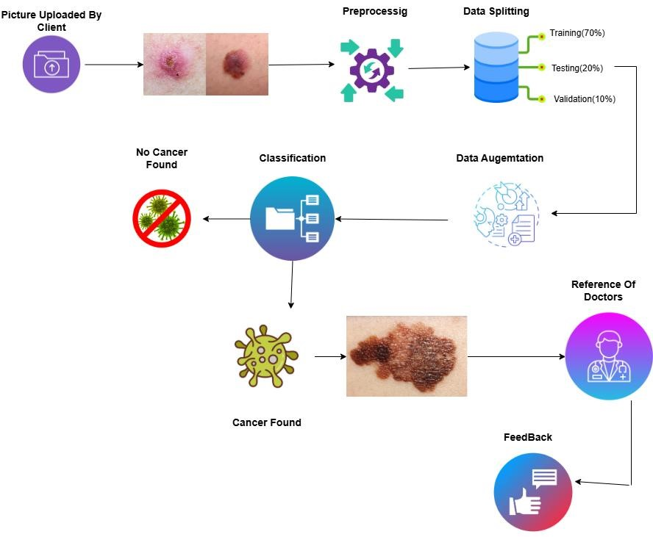
Figure 1: Proposed Methodology
Dataset:
HAM10000 Dataset is used. Which is available publicly.

Model Training:
The Model is trained on preprocessed and augmented dermatoscopic images from Dataset HAM10000 to classify and segment skin lesions into benign and malignant categories.

System Integration:
When the Model is trained and integrated into a user-friendly Web or Mobile Application, it will allow users to Upload skin lesion images and receive the real time skin cancer risk predictions and visual segmentation outputs.

Alert Mechanism:
Upon Detecting a Skin Cancer, the system triggers an alert notification recommending immediate medical Consultation.
Testing and Validation:
Thoroughly check the system to validate overall performance and accuracy.

3.3 System Architecture
The system architecture is designed to ensure seamless operation and integration of various components.
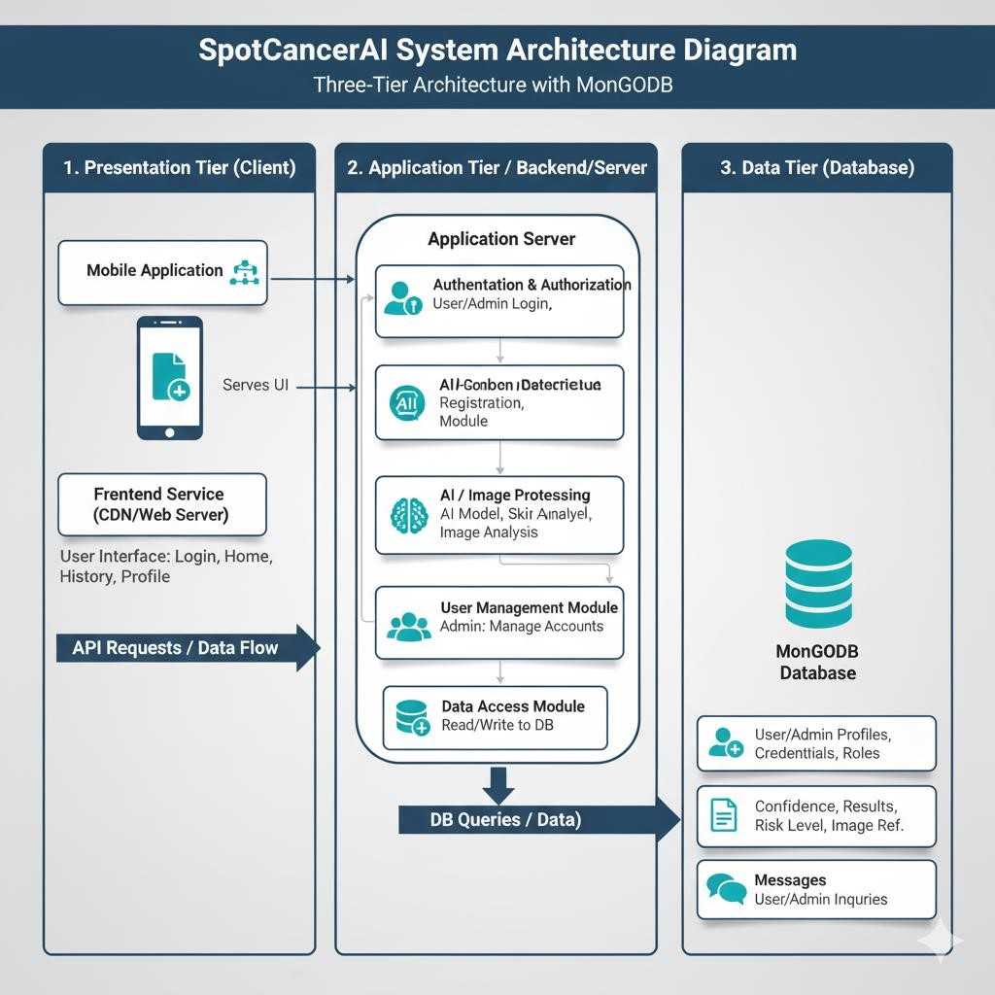
Figure 2 : System Architecture Diagram

3.3.1 Description of Components
Frontend (Web/Mobile App):
The user Interface where Users can upload Dermatoscopic Images for analysis and get accurate results.

Backend (Flash/FastAPI):
It communicates between the frontend and trained model. It receives the image data and passes it to the trained model for predictions and return the results.

Trained Model:
A deep learning model that has been trained on preprocessed data to classify and segment skin lesions into categories such as benign or malignant.
Database:
It stores the user information, image data, prediction results. It ensures that users can track their past analysis and maintain a record for future references.

Alert System:
An automated alert system triggers notification when a potentially high-risk or malignant lesion is detected. These notifications can be sent to the user via email or through the app.

3.4 Use Cases
The following are the use cases for the SpotCancerAI System as described in this section. Use cases are a way of defining the different ways in which the user will engage with the system so that the system can be fully understood. The following is a list of the use cases with brief description, actors, and pre and post conditions as well as the flow of events.

Patient/User:

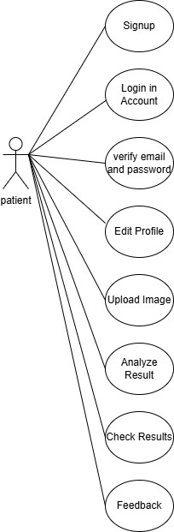
Dermatologist:
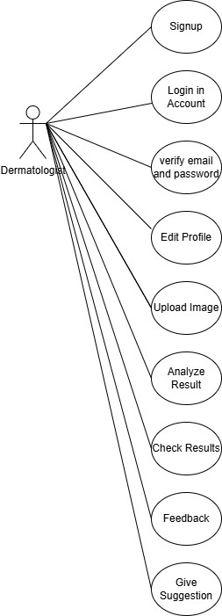
System Admin:
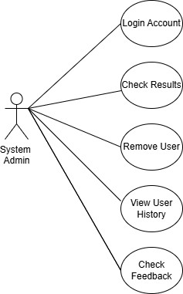
Combine Users
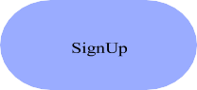
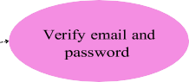
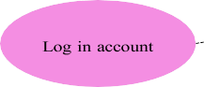
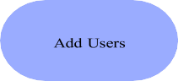
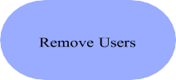
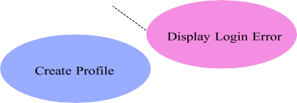
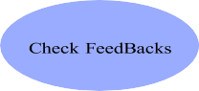
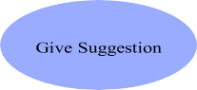
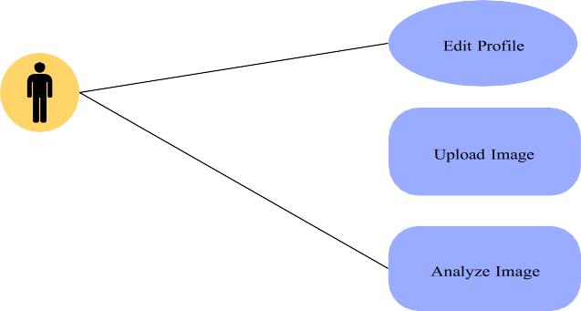

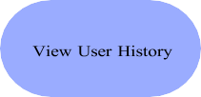
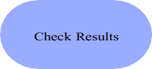
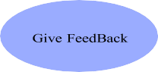

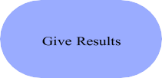

<
<
in
c

l
u
de

>
>

E
x
t
e
n
d

Fully Dressed Use Case:
3.4.1 SignUp:

Table 2: Signup

Name | Sign up
Actors | User, Dermatologists, Admin
Summary | The user creates a new account by providing necessary information.
Pre-  Conditions | None
Post-  Conditions | The user successfully creates a new account and can log in to the system.
Special  Requirements | None
Basic Flow

Actor Action |  | System Response
1 | The user opens the sign-up page. | 2 | The sign-up page is displayed, asking for the user's information such as name, email, and password.
3 | The user enters their name, email, and password.
4 | The user submits the sign-up form. | 5 | The system verifies the provided information and creates a new account for the user.
 |  | 6 | The system displays a success message, informing the user that their account has been created.
Alternative Flow
4.1 | If the user submits the sign-up form with incomplete or invalid information. | 4.2 | The system responds with an error message, indicating the specific fields that need to be corrected.

3.4.2 Login:

Table 3: Login
Name |  | Login
Actors |  | Admin, User, Dermatologist
Summary |  | The user shall provide their email and password on the login form and after successful verification, redirect the user to the home page.
Pre-  Conditions |  | User must be registered on the system.
Post-  Conditions |  | The user shall be redirected to the home page of the system and user’s session will be maintained.
Special  Requirements |  | None
Basic Flow
Actor Action |  |  | System Response
1 | The user opens the login page. |  | 2 | The login page is displayed asking for email and password.
3 | The user enters valid email and password. |  | 4 | The system verifies the email and password, establishes a session for the user and redirects the user to the home page.
Alternative Flow
3.1 | The user enters invalid email or password. |  | 3.2 | The system responds with an error message: Incorrect email or password entered.

3.4.3 Create Profile:

Table 4: Create Profile

Name |  | Create Profile
Actors |  | User, Dermatologists
Summary |  | This use case describes the process of creating a profile for a user on the SpotCancerAI platform.
Pre-  Conditions |  | The user must have access to the SpotCancerAI website.  The user must be registered on the SpotCancerAI platform.
Post-  Conditions |  | The user's profile is successfully created and can be viewed by others on the platform.
Special  Requirements |  | None
Basic Flow
Actor Action |  |  | System Response
1 | User navigates to the SpotCancerAI website.
2 | User clicks on the "Create Profile" or "Sign Up" button. |  | 3 | The system presents a profile creation form.
4 | User enters their personal details, such as name, email address, username, profile picture etc., in the provided fields.
5 | User clicks on the "Submit" or "Create Profile" button. |  | 6 | The system validates the entered information.
 |  |  | 7 | The system saves the user's profile information in the SpotCancerAI database.
 |  |  | 8 | The system displays a confirmation message indicating that the profile has been successfully created.
Alternative Flow
4.1 | If the user enters incomplete or invalid information in the profile creation form. |  | 4.2 | Then the system displays error messages and prompts the user to correct the entries.
4.3 | If the chosen username is already taken by another user. |  | 4.4 | Then the system prompts the user to choose a different username.

3.4.4 Upload Image:

Table 5: Upload Image

Name |  | Upload Image
Actors |  | Admin, User, Dermatologists
Summary |  | The user shall upload a skin image through the interface for analysis or record-keeping. The system validates and stores the image in the database.
Pre-  Conditions |  | User must be logged in on the system.
Post-  Conditions |  | The user shall be redirected to the home page of the system and user’s session will be maintained.
Special  Requirements |  | None
Basic Flow
Actor Action |  |  | System Response
1 | The user navigates to the "Upload Image" section. |  | 2 | The system displays an upload interface with file selection.
3 | The user enters valid email and password. The user selects a valid skin image file. |  | 4 | The system previews the image and shows an "Upload" button.
5 | The user clicks the "Upload" button. |  | 6 | The system validates the file format and size and upload image.
Alternative Flow
3.1 | The user enters invalid email or password. User selects an unsupported format. |  | 3.2 | The system responds with an error message: The system shows an error:  "Unsupported file format.

3.4.5 Analyze Image:
Table 6: Analyze Image

Name |  | Analyze Image
Actors |  | Admin, User, Dermatologists
Summary |  | The user shall upload a skin image through the interface for analysis or record-keeping. After an image is uploaded, the user can request the system to analyze the skin image using a trained machine learning model. The system returns a prediction (e.g., benign or malignant).
Pre-  Conditions |  | A valid image must be uploaded. The user must be logged in.
Post-  Conditions |  | The prediction result is generated, stored, and displayed to the user.
Special  Requirements |  | None
Basic Flow
Actor Action |  |  | System Response
1 | The user navigates to the "Upload Image" section. |  | 2 | The system displays a button or option to analyze the selected image.
3 | The user clicks the "Analyze" button. |  | 4 | The system sends the image to the trained AI model for classification.
5 | The model processes the image and generates prediction. |  | 6 | The system displays the result (e.g., "Benign" or "Malignant") with confidence % and store result in Database.
Alternative Flow
3.1 | Image is corrupted or unreadable. |  | 3.2 | The system displays: "Image format invalid or unreadable. Please upload a new image."

3.4.6 Add users:
Table 7: Add users

Name |  | Add Users
Actors |  | Admin
Summary |  | This use case describes the process of adding users to the SpotCancerAI platform.
Pre-  Conditions |  | The actor (Administrator) must have the necessary privileges and permissions to add users.  The actor must be logged in to their SpotCancerAI account.
Post-  Conditions |  | The new users are successfully added to the SpotCancerAI platform.
Special  Requirements |  | None
Basic Flow
Actor Action |  |  | System Response
1 | Actor logs in to their SpotCancerAI account with appropriate privileges (Administrator).
2 | Actor navigates to the user management or account administration section of the SpotCancerAI platform.
3 | Actor selects the option to add users or create new accounts. |  | 4 | The system presents a form or interface to enter user details, such as email address, username, and other relevant information.
5 | Actor fills in the required user information, ensuring the accuracy and completeness of the data. |  | 6 | The system validates the entered information, checking for any potential errors or conflicts (e.g., duplicate email addresses, invalid usernames).
7 | Actor submits the form or clicks on the "Add User" button to initiate the user creation process. |  | 8 | The system processes the user creation request and generates a new user account.
 |  |  | 9 | The system displays a confirmation message indicating that the user has been

 |  |  | successfully added to the SpotCancerAI platform.
10 | The new user receives an email or notification containing their login credentials and instructions for accessing the platform.
Alternative Flow
7.1 | If there are any issues during the user creation process, such as validation errors or database constraints. | 7.2 | the system displays an error message and advises the actor to review and correct the provided information

3.4.7 Remove Users:

Table 8: Remove Users

Name |  | Remove user
Actors |  | Admin
Summary |  | This use case describes the process of removing users from the SpotCancerAI platform. The removal can only be performed by the administrator.
Pre-  Conditions |  | The administrator must have the necessary privileges and permissions to remove users.  The administrator must be logged in to their SpotCancerAI account.
Post-  Conditions |  | The selected users are successfully removed from the SpotCancerAI platform.
Special  Requirements |  | None
Basic Flow
Actor Action |  |  | System Response
1 | Administrator logs in to their  SpotCancerAI account with appropriate privileges.
2 | Administrator navigates to the user management or account administration section of the SpotCancerAI platform.
3 | Administrator views the list of users on the platform.
4 | Administrator selects one or multiple users to be removed.
5 | Administrator confirms the selection and initiates the removal process. |  | 6 | The system prompts the administrator to confirm the removal action, ensuring they understand the consequences.
7 | Administrator confirms the removal action. |  | 8 | The system processes the removal request and deletes the selected users' accounts from the SpotCancerAI platform.
 |  |  | 9 | The system displays a confirmation message indicating that the users have been successfully removed.
Alternative Flow
5.1 | If there are any issues during the user removal process, such as database errors or system constraints. |  | 5.2 | The system displays an error message and advises the administrator to retry.

3.4.8 Check Results:

Table 9: Check Results

Name |  | Check Results
Actors |  | Admin, User, Dermatologists
Summary |  | The user can view the prediction results of previously analyzed skin images, including diagnosis, date, and confidence score.
Pre-  Conditions |  | At least one image must have been analyzed by the system.
Post-  Conditions |  | The prediction result is generated, stored, and displayed to the user.
Special  Requirements |  | None
Basic Flow
Actor Action |  |  | System Response
1 | The user logs into the system. |  | 2 | The system redirects to the dashboard/home page.
3 | The user navigates to the "Results" or "History" section. |  | 4 | The system fetches the list of all analyzed images and their results.
5 | The user selects a specific result to view details.. |  | 6 | The system displays the result (diagnosis, confidence, date, and image preview).
Alternative Flow
4.1 | No results available for user. |  | 4.2 | The system displays: "No analysis results  found. Please upload and analyze an image first."

3.4.9 View User History:

Table 10: View User History

Name |  | View User History
Actors |  | Admin, User, Dermatologists
Summary |  | The user can view a complete history of all uploaded images and their associated prediction results (if analyzed).
Pre-  Conditions |  | The user must be logged into the system.
Post-  Conditions |  | A list of all uploaded images and their statuses is displayed.
Special  Requirements |  | None
Basic Flow
Actor Action |  |  | System Response
1 | The user clicks on “History” or “My Uploads.” |  | 2 | The system queries the database for all uploaded images associated with the user.
3 | The system displays a list including image, upload date, status (Analyzed / Pending), and result (if available).
4 | The user selects a specific result to view details.. |  | 5 | The system displays the result (diagnosis, confidence, date, and image preview).
Alternative Flow
4.1 | No results available for user. |  | 4.2 | The system displays: "No analysis results found.
5.1 | Database fetch fails. |  | 5.2 | The system displays: "Unable to load history. Please try again later."

3.4.10 Give suggestions:
Table 11: Give Suggestions

Name |  | Give Suggestions
Actors |  | Dermatologists
Summary |  | After analyzing a skin image, the system or dermatologist provides suggestions such as recommended next steps, care tips, or referrals based on the prediction result.
Pre-  Conditions |  | A prediction result must exist for the image.
Post-  Conditions |  | Suggestions are displayed to the user and stored with the image record.
Special  Requirements |  | None
Basic Flow
Actor Action |  |  | System Response
1 | The system completes image analysis and stores prediction. |  | 2 | System checks prediction result (e.g., Benign / Malignant)
3 | System generates auto-suggestions (or dermatologist adds notes). |  | 4 | Suggestions are stored and linked with the corresponding result.
5 | User views the result page. |  | 6 | System displays the diagnosis along with appropriate suggestions.
Alternative Flow
4.1 | No suggestion template available. |  | 4.2 | System shows a general message: “Consult a dermatologist for further guidance.”

3.4.11 Provide Feedbacks:

Table 12: Provide Feedbacks

Name | Provide feedback
Actors | User, Dermatologists
Summary | This use case describes the process of providing feedback on the SpotCancerAI.
Pre-  Conditions | • The user must have a registered account on the SpotCancerAI platform. • The user must be logged in to their SpotCancerAI account.
Post-  Conditions | The user's feedback is successfully submitted and received by the SpotCancerAI platform.

Special  Requirements |  | None
Basic Flow
Actor Action |  |  | System Response
1 | User navigates to the SpotCancerAI website and logs in to their account.
2 | User locates the feedback section or finds the designated area for providing feedback.
3 | User clicks on the "Give Feedback" button. |  | 4 | The system presents a feedback form or text box.
5 | User enters their feedback in the provided text area, providing specific details and information.
6 | User clicks on the "Submit" or "Send" button to submit the feedback. |  | 7 | The system captures and stores the user's feedback in the SpotCancerAI platform.
 |  |  | 8 | The system displays a confirmation message indicating that the feedback has been successfully submitted.
Alternative Flow

3.4.12 View FeedBacks:

Table 13: View FeedBacks

Name | View feedback
Actors | Admin
Summary | The Admin can view all feedback submitted by users or Dermatologists, including comments on system performance, prediction quality, and feature suggestions.
Pre-  Conditions | The Admin must be logged in. At least one feedback must exist in the database.
Post-  Conditions | Feedbacks are retrieved and displayed with user details and timestamps.
Special  Requirements | None
Basic Flow
Actor Action |  | System Response

1 | Admin logs into the system. | 2 | System redirects to Admin Dashboard.
3 | Admin clicks on the “View Feedbacks” module. | 4 | System fetches all feedback entries from the database.
5 | Admin views feedback list, including: user name, role, date, feedback content, and associated prediction ID (if applicable). | 6 | System displays results with filter and sort options (e.g., by date, user type).
Alternative Flow
4.1 | System displays results with filter and sort options (e.g., by date, user type). | 4.2 | System displays: “No feedbacks have been submitted yet.”

3.5 GUI Graphical User Interfaces

3.5.1 Home Screen (Role Selection Interface)

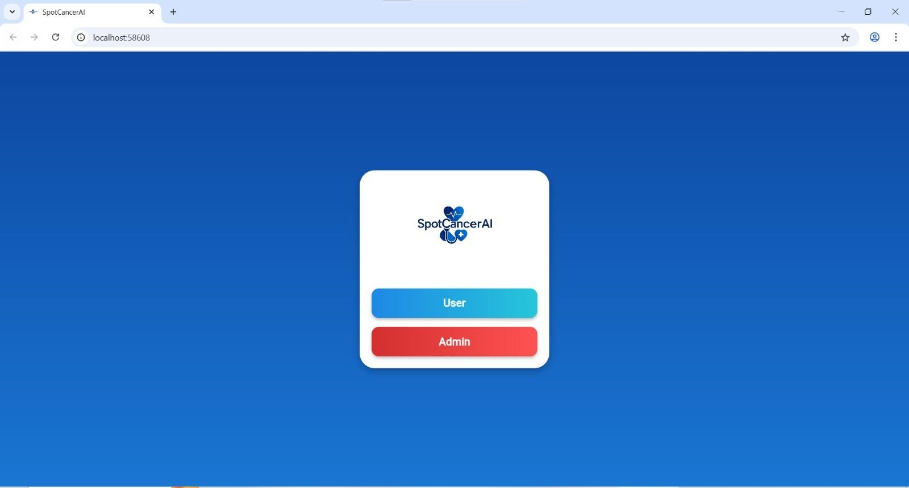

The Home Screen serves as the primary entry point of the SpotCancerAI system, presenting users with two main access options—User and Admin—to guide them toward the appropriate login module. The interface features a clean and modern design with a gradient blue background, while the SpotCancerAI logo is prominently displayed at the top of the centered card, creating a welcoming and professional appearance. This screen is designed to help users easily identify their role before proceeding, ensuring a clear separation between standard user functions and administrative access. The User button, styled with a blue gradient, directs individuals to the standard login page, whereas the Admin button, highlighted in a red gradient, leads to the administrator login panel, reinforcing the distinction between general and advanced system privileges.

3.5.2 User Login Screen
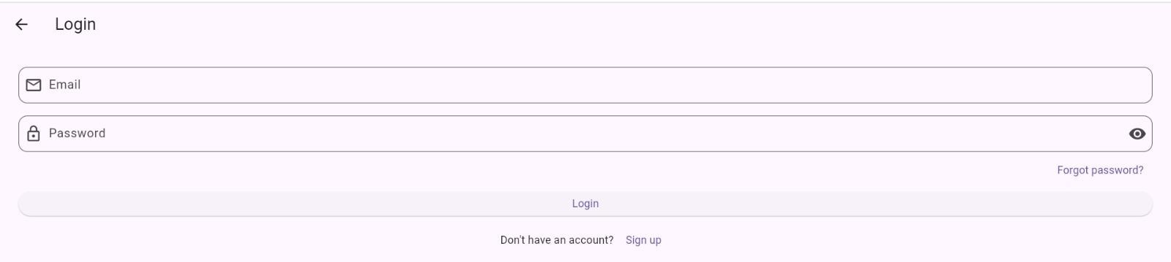

The User Login Screen provides a secure and user-friendly interface for patients or doctors to authenticate themselves before accessing the system’s features. It incorporates a minimalistic layout with soft, light-toned colors that enhance readability and comfort for users. The screen includes fields for entering a registered email and password, with the password field offering a visibility toggle to improve usability. A clearly marked login button initiates the authentication process, while additional options such as "Forgot Password" allow users to recover access if necessary. The screen also includes a signup link, enabling new users to quickly create an account and begin using the system. Overall, the interface focuses on simplicity, accessibility, and a smooth login experience.

3.5.3 Admin Login Screen

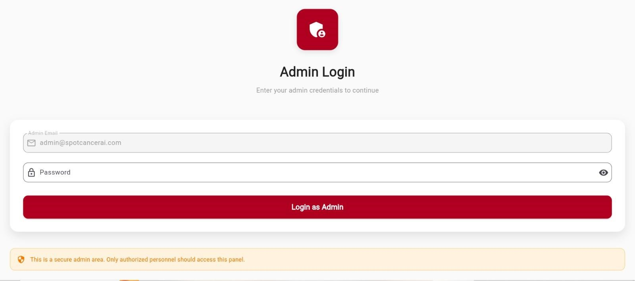

The Admin Login Screen is specifically designed for system administrators who manage backend operations, user permissions, and overall system security. It utilizes a bold red color theme that visually communicates the sensitive and restricted nature of administrative access. The screen includes dedicated fields for entering an admin email and password, both equipped with secure input formatting and a visibility toggle to reduce login errors.
The “Login as Admin” button validates credentials and grants access to the administrative dashboard. Additionally, a distinct security notice is displayed to remind users that the section is intended only for authorized personnel. The overall design emphasizes security, clarity, and controlled access to ensure proper handling of system-level functionalities.

3.5.4 Dashboard Screen (Main User Interface)

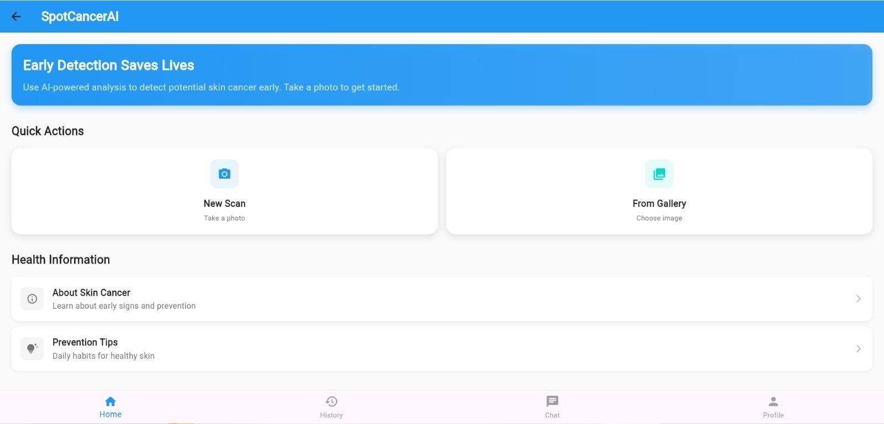

The Dashboard Screen serves as the central hub of the SpotCancerAI application, providing users with seamless access to all major functionalities in a clean and intuitive layout. From this screen, users can upload a dermoscopic image directly from their device or capture a new image using the built-in camera feature for instant analysis. The dashboard also includes a dedicated section for health information, where users can learn about different skin lesion types, prevention methods, and early detection guidelines. A "Tips" panel offers expert-recommended practices for maintaining healthy skin and identifying warning signs of melanoma. Additionally, users can view their complete analysis history, allowing them to track previous scans and monitor any changes over time. The screen also integrates a contact option for reaching out to support or medical professionals when assistance is needed. A built-in chat feature enables real-time communication with healthcare experts or system support. Finally, a profile section allows users to manage their personal information, account settings, and preferences. Overall, the dashboard is designed for easy navigation, delivering a smooth and informative user experience tailored to both patients and medical practitioners.

3.5.5 Analysis Result Screen

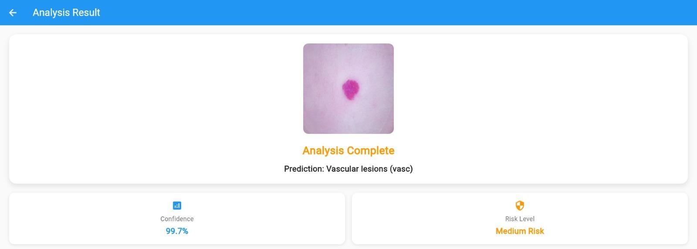

The Analysis Result Screen presents a clear and comprehensive summary of the outcome generated by the SpotCancerAI model after processing the uploaded or captured skin image. This interface displays the predicted class of the skin lesion—such as melanoma, nevus, or keratosis—allowing users and clinicians to immediately understand the model’s diagnostic interpretation. Along with the predicted category, the screen provides the confidence score, which quantifies how certain the model is about its prediction, offering additional insight into decision reliability. The system also calculates and displays a risk level (low, moderate, or high), helping users gauge the urgency of seeking medical attention. The results are presented in a visually structured format, often accompanied by color-coded indicators to enhance readability and support quick evaluation. Overall, the Analysis Result Screen is designed to deliver accurate, interpretable, and user-friendly diagnostic feedback that supports informed medical decision-making.

Implementation and Test Cases

4.1. Introduction
The implementation of the proposed skin cancer classification system involves the development of a deep learning-based pipeline designed to accurately identify and categorize various types of skin cancer lesions. The system processes dermatological images through a sequence of well-defined stages, beginning with the detection of skin regions and culminating in the classification of skin cancer into seven distinct categories. These categories include Actinic Keratoses (akiec), Basal Cell Carcinoma (bcc), Benign Keratosis-like Lesions (bkl), Dermatofibroma (df), Melanoma (mel), Nevus (nv), and Vascular Lesions (vasc).
This section presents a comprehensive overview of the proposed methodology, encompassing dataset preparation, pipeline architecture, and model training and evaluation.

4.2. Implementation

4.2.1. Proposed Framework
We propose a deep learning-based skin cancer classification pipeline using the HAM10000 dataset, which includes seven categories of skin lesions. The system employs an EfficientNetB5-based Convolutional Neural Network (CNN) to perform precise multi-class classification across Actinic Keratoses (akiec), Basal Cell Carcinoma (bcc), Benign Keratosis-like Lesions (bkl), Dermatofibroma (df), Melanoma (mel), Nevus (nv), and Vascular Lesions (vasc). The model leverages transfer learning and extensive data preprocessing to enhance feature extraction and classification accuracy. This approach provides a reliable, efficient, and scalable framework for automated skin cancer diagnosis.

4.2.1.1. Pipeline Overview

4.2.1.1.1. Multi-Class Classification with EfficientNet
The proposed system employs a seven-class skin cancer classification model based on the EfficientNet architecture, trained on the HAM10000 dataset. Since the dataset exclusively contains dermoscopic images of skin lesions, no preliminary filtering is required. The model performs multi-class classification across seven categories: Actinic Keratoses (akiec), Basal Cell Carcinoma (bcc), Benign Keratosis-like Lesions (bkl), Dermatofibroma (df), Melanoma (mel), Nevus (nv), and Vascular Lesions (vasc).
To address the dataset’s class imbalance, techniques such as data augmentation and class weighting are applied during training. The EfficientNet model is fine-tuned using transfer learning to leverage pre- trained ImageNet features for improved accuracy and generalization. This stage serves as the core of the pipeline, enabling precise and efficient classification of skin cancer lesions based on dermoscopic imagery.

4.2.1.1.2. Multi-Class Classification with Essemble Model
The second stage of the proposed pipeline employs a multi-class skin cancer classification model trained on the HAM10000 dataset, which includes seven diagnostic categories: Actinic Keratoses (akiec), Basal Cell Carcinoma (bcc), Benign Keratosis-like Lesions (bkl), Dermatofibroma (df), Melanoma (mel), Nevus (nv), and Vascular Lesions (vasc). To enhance performance, an ensemble model combining EfficientNet-B5 and EfficientNet-B1 architectures was implemented. The ensemble approach aimed to leverage the complementary strengths of both networks to improve generalization and classification accuracy.
Although class balancing techniques such as data augmentation and class weighting were applied during training, the ensemble model did not yield significant improvements compared to the individual models. This performance limitation may be attributed to overlapping feature representations between the two EfficientNet variants or insufficient model diversity. Future enhancements could involve combining more heterogeneous architectures, employing
Advanced ensemble fusion strategies (e.g., stacking or weighted averaging), and refining data balancing methods to better address class distribution disparities within the HAM10000 dataset.

4.2.1.1.3 Performance of Inception and ResNet Models on HAM10000
In the third stage, Inception and ResNet architectures were individually trained on the HAM10000 dataset for seven-class skin cancer classification. However, both models demonstrated poor performance and failed to achieve satisfactory accuracy or generalization. This limited performance can be attributed to the high class imbalance inherent in the dataset, as well as the visual similarity among certain lesion types, which makes fine-grained classification challenging.
Moreover, both architectures struggled to extract discriminative features due to variations in image quality, lighting, and lesion texture. Despite applying standard preprocessing, data augmentation, and class balancing techniques, the models exhibited overfitting and low sensitivity for minority classes such as Actinic Keratoses (akiec) and Dermatofibroma (df). The results suggest that Inception and ResNet are not well-suited for this specific dataset without significant architectural adaptation or specialized preprocessing.

4.2.1.1.4 Final Multi-Class Skin Cancer Classification Using

EfficientNetB5
In the final stage, the EfficientNetB5 architecture was employed for seven-class skin cancer classification using the HAM10000 dataset. To address the challenges of class imbalance and improve model robustness, data augmentation and focal loss were applied during training. Random augmentation techniques, including rotation, flipping, zooming, and brightness adjustments, were utilized to increase dataset diversity and reduce overfitting.
The model demonstrated strong performance, achieving over 90% training accuracy and 84% validation accuracy, indicating effective generalization across unseen data. The integration of focal loss helped the model focus more on minority classes, enhancing sensitivity and reducing bias toward dominant categories such as Nevus (nv).
Overall, this stage produced the best results among all configurations, confirming that the combination of EfficientNetB5, focal loss, and random augmentation forms a highly effective framework for accurate and balanced skin cancer classification using the HAM10000 dataset.
The pipeline’s architecture is illustrated in the Figure, which depicts the flow from input image processing through skin detection to disease classification. This visual representation highlights the sequential nature of the framework and the role of each model in achieving the overall objective of accurate skin disease diagnosis.
Figure 3: Skin Cancer Classification

4.2.2. Dataset

We utilized the HAM10000 dataset for our CNN-based skin disease classification pipeline. This dataset contains 10,015 dermatoscopic images across seven disease categories, enabling both robust preprocessing and accurate multi-class classification. The distribution spanning melanocytic nevi (6,705), melanoma (1,113), benign keratosis (1,099), basal cell carcinoma (514), actinic keratoses (327), vascular lesions (142), and dermatofibroma (115) informed our class balancing strategy to ensure reliable model training and evaluation.

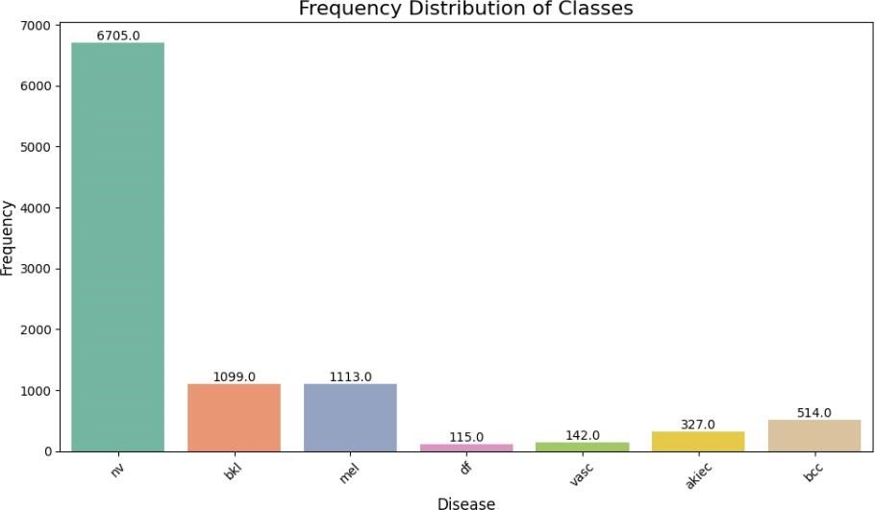

Figure 4: Distribution of Classes

4.2.2.1 Solving Data Imbalance
The HAM10000 dataset suffers from severe class imbalance, with melanocytic nevi dominating (67%) while rare classes like dermatofibroma are underrepresented (1.1%). This imbalance would bias the model toward majority classes.
We solved this through data augmentation applying rotations, flips, and brightness adjustments—with more aggressive augmentation for minority classes. Combined with class- weighted loss functions that assigned higher penalties for misclassifying rare diseases, this approach ensured balanced learning across all categories and improved detection of both common and rare conditions.
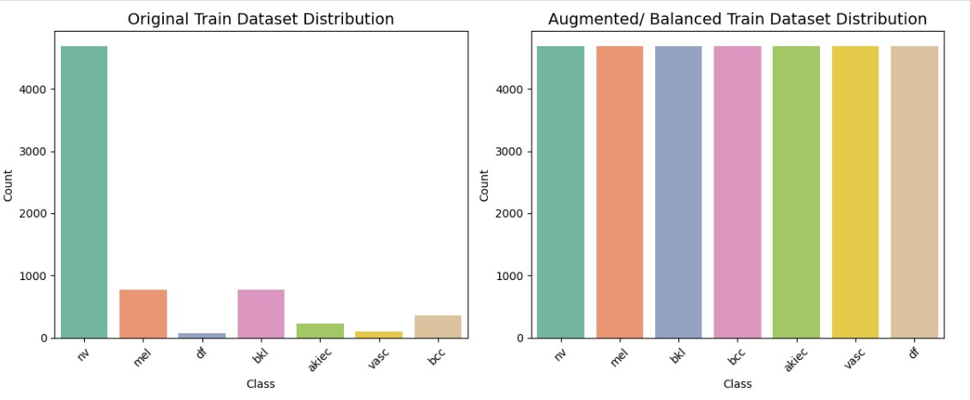

4.2.3 Preprocessing Image

The preprocessing pipeline standardizes dermatological images through systematic hair removal using morphological operations and exemplar-based inpainting, followed by dimensional normalization to 456×456 pixels using Lanczos interpolation. Color consistency is maintained through RGB conversion, while adaptive thresholding ensures precise detection of occluding structures. This comprehensive preprocessing framework preserves critical diagnostic features and ensures input homogeneity for subsequent convolutional neural network analysis, significantly enhancing model reliability and classification accuracy.

Original Preprocess Image (456x456)

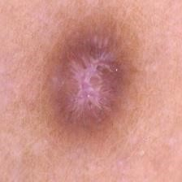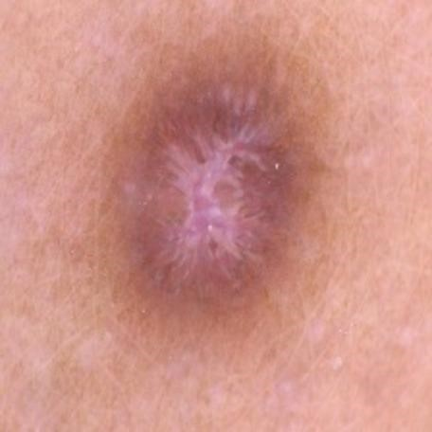

Figure 5: Image Preprocessing

4.2.4 Dataset Splitting
The HAM10000 dataset was partitioned into standardized training, validation, and test subsets to facilitate robust model development and evaluation. The dataset was divided into 7,010 images (70.00%) for training, 1,001 images (10.00%) for validation, and 2,004 images (20.01%) for testing.

Before Balance:
Table 14: Dataset Before Balancing

Split Type | Number of Images | Percentage
Train | 7,010 | 70.00%
Validation | 1,001 | 10.00%
Test | 2,004 | 20.00%
Total | 10,015 | 100.00%

After Balance:
Table 15: Dataset After Balancing

Split Type | Number of Images | Percentage | Notes
Train | 32,851 | 91.60% | After augmentation & balancing
Validation | 1,001 | 2.79% | Original samples only
Test | 2,004 | 5.59% | Original samples only
Total | 35,856 | 100% | After balancing procedures

4.2.5 CNN Architecture

The convolutional neural network architecture developed for dermatological image classification employs a sophisticated transfer learning framework centered on EfficientNetB5 as the core feature extractor. This backbone network, pre-trained on the extensive ImageNet dataset, provides a robust foundation for visual pattern recognition, which is particularly advantageous for medical imaging tasks with limited annotated data. The architectural implementation begins with strategic fine-tuning methodology, where the initial 200 layers remain frozen to preserve generic feature detection capabilities, while subsequent layers are made trainable to adapt the network to domain-specific dermatological characteristics and lesion patterns.
The custom classification head demonstrates a carefully engineered progressive dimensionality reduction approach, transitioning through 512, 256, and 128 fully-connected units. Each dense layer incorporates Swish activation functions, recognized for superior performance in deep networks compared to traditional ReLU, accompanied by L2 regularization (λ=1e-4) to constrain weight magnitudes and prevent overfitting. Batch normalization layers are systematically integrated after each dense layer to stabilize training dynamics and accelerate convergence through internal covariance shift reduction. A descending dropout strategy is implemented with rates of 0.5, 0.3, and 0.2 respectively, providing progressively stronger regularization in earlier layers while allowing more precise feature learning in deeper layers.
The optimization framework addresses the critical challenge of class imbalance through a customized categorical focal loss function with hyperparameters γ=3.0 and α=0.5, which dynamically scales the loss to focus learning on misclassified examples and balance class contributions. Model compilation utilizes the Adam optimizer with a conservative learning rate of 1e-5 to ensure stable gradient updates during fine-tuning. Comprehensive evaluation metrics include standard categorical accuracy, area under the ROC curve (AUC) for diagnostic capability assessment, and top-3 categorical accuracy to capture clinical relevance where multiple differential diagnoses may be considered. This multi-faceted architectural design ensures robust feature extraction, effective regularization, and clinically meaningful performance evaluation for automated skin disease classification.
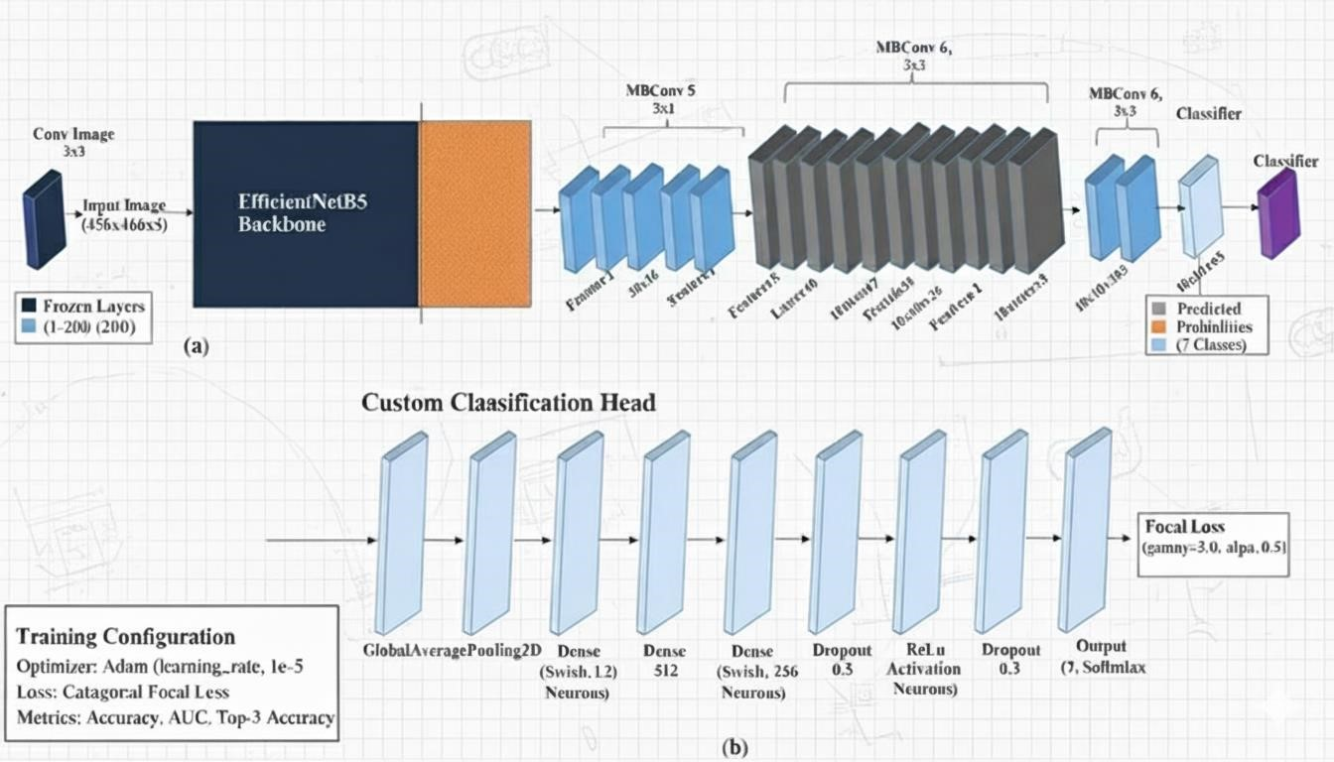

Figure 6: CNN Architecture

4.2.6 Activation and Loss Function Activation Function (Softmax):
Used in the output layer to convert logits into class probabilities.

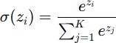

It ensures all output values are between 0 and 1 and sum to 1, suitable for multi-class classification. Loss Function (Categorical Focal Loss):
Focuses training on hard, misclassified examples by reducing the weight of well- classified ones.

Here, pt is the predicted probability for the true class, α\alphaα balances class weights, and γ\gammaγ controls the focusing strength.

4.2.7 Model Training
The model training was performed on Kaggle’s GPU environment, which provided the necessary computational power for deep learning operations. The proposed architecture utilized EfficientNetB5 as the base model with ImageNet pre-trained weights for transfer learning, enabling efficient feature extraction from skin lesion images. Custom fully connected layers with Swish activations, Batch Normalization, and Dropout regularization were added to enhance learning stability and prevent overfitting. The model was fine-tuned by unfreezing the last layers of EfficientNetB5 to adapt to the HAM10000 dataset. The training process employed the Adam optimizer with a learning rate of 1e-5, chosen for its adaptive gradient handling and stable convergence. The categorical focal loss function was used to focus learning on harder, misclassified samples, improving robustness against class imbalance. Performance metrics included accuracy, AUC, and Top-3 categorical accuracy, allowing comprehensive evaluation of the model’s classification capability across seven skin disease categories.

4.2.8 Model Evaluation
The evaluation of the trained model was conducted using standard performance metrics, including Precision, Recall, F1-Score, and the Confusion Matrix, comprehensively assess its classification effectiveness. Precision measures the proportion of correctly predicted positive samples among all predicted positives, reflecting the model’s accuracy in identifying true cases. Recall (or Sensitivity) evaluates the model’s ability to correctly detect all actual positive cases, ensuring minimal false negatives. The F1-Score, being the harmonic mean of Precision and Recall, provides a balanced assessment of the model’s accuracy and robustness, particularly in handling class imbalance. Additionally, the Confusion Matrix visually represented the distribution of true and false classifications across all seven skin disease categories, enabling detailed insight into model performance and misclassification trends. Together, these metrics confirmed the model’s reliability and strong discriminative capability in accurately identifying various types of skin lesions.

4.2.9 Conclusion

The implementation of the proposed pipeline demonstrates a systematic approach to handling complex datasets and achieving effective classification. Despite challenges such as dataset imbalance and noise, the system effectively identifies and classifies skin diseases in a two-stage process. Continuous dataset improvements and model optimizations are expected to enhance performance further.

